©VIT IPR&TTCELL
Document No.
Invention Disclosure Format (IDF)-B
Issue No/Date
Amd. No/Date


- Title of the invention:

Active-Acoustic Urban Drain Blockage Detection and Early Flood Warning System using ESP32-Based Multi-Sensor Fusion

- Field /Area of invention:

The current invention belongs to the following domains of science: Environmental Monitoring, Internet of Things (IoT), Embedded Systems, Smart City Infrastructure, Machine Learning, and Urban Flood Management.

It is more specific and focuses on developing a cheap system for monitoring the urban drainage network, which includes sensors and embedded computing technology along with wireless communications for detecting blockages and floods.

- Prior Patents and Publications from literature (provide a table summarizing the prior art)

Patent/Publication | Description | Relevance to invention
CN104899321A | Urban drainage monitoring system with water level sensors | The system primarily utilizes water-level sensors to detect overflows. Even though the sensor can be effective in cases of floods, the sensor works under the principle of thresholds, whereby there must be an occurrence of critical situations for it to respond. However, the current proposal of the system integrates depth, flow, and pressure readings for prediction of blockages at an early stage.
JP6248413B2 | Water flow-based warning systems | The system depends on flow monitoring to detect any faults, but it cannot detect blockages in their initial stages because no significant changes occur in the flow. The invention is an improvement since it incorporates the water depth parameter alongside flow and pressure to detect blockages effectively.
KR20110031923A | Environmental alert systems | The patent describes an overall methodology for tracking environmental factors and sending notifications. Yet, there is no specific consideration related to drainage management in the patent, and also, it is not based on machine learning for prediction and relies mainly on thresholds-based alerts. This proposed methodology takes advantage of both AI predictions and sensor fusion.
IEEE Papers on IoT Flood Monitoring | Sensor-based flood alert systems | Current solutions for these problems use monitoring that is based on one parameter (water level), which triggers an alert only if some threshold values are crossed. In this way, the root cause (blockage forming) is not efficiently detected by current solutions. On the contrary, the presented invention utilizes a combination of different parameters monitored using machine learning technology.
IEEE Paper on Flood Prediction using Machine Learning | Application of machine learning models to predict flood conditions based on historical data | This method shows that machine learning techniques can be used successfully in the case of flood prediction. However, this method lacks integration with live hardware sensor devices. There are no real-time data updates provided through this technique. This invention fills this gap by integrating machine learning with the live data acquisition process through ESP32 sensors.

- Summary and background of the invention (Address the gap / Novelty)

Urban flooding has emerged as one of the main issues faced by modern cities owing to fast urbanization, improper waste disposal, and inadequate drainage facilities. Urban floods are usually caused by the obstruction of drainage systems due to the accumulation of solid waste, sedimentation, and limited flow through pipes. Obstructions decrease the capacity of the drainage system, eventually resulting in the overflow of floodwater after rainfall.

Currently used monitoring systems depend either on manual inspection or detecting the presence of a threshold water level. Although such methods work effectively for determining the start of a flood, they are unable to give advance warning of obstructions, hence being mostly reactive instead of preventive. Consequently, appropriate measures cannot be taken on time, resulting in further floods.

This project involved training a Random Forest model using data associated with previous floods, which resulted in an approximate 85-87.5% of accuracy. Water depth turned out to be the main feature impacting the probability of a flood occurrence. Nevertheless, it does not suffice to determine the causes of abnormal behavior, especially in terms of separating natural elevation from the presence of obstructions.

In response to this drawback, the suggested invention presents an AI-enabled multi-sensor drainage system, consisting of the following:

- Water level sensor (mainly responsible parameter)
- Flow rate sensor (first sign of the blockage presence)
- Pressure sensor (obstruction indication in the pipe)

One of the unique features of the invention is an ability to combine information derived from machine learning analysis together with hardware functionality. Although the results obtained with the help of ML show that water level is the main predictor, practical observations have revealed the following pattern:

- Flow drops before any water accumulates
- The increase in pressure is observed due to the resistance generated by the obstruction
- An increase in water depth occurs when the blockage is severe enough

Combining all three signs mentioned above, it is possible to predict the presence of blockages during their early stages, which is impossible with traditional approaches based on a single parameter.

Moreover, the system includes a cost-efficient way of simulating real-life drainage conditions with the help of a circulation setup based on PVC pipes.

In conclusion, the proposed invention offers a combination of hardware capabilities, ML algorithms, and IoT technology to provide efficient protection against urban flooding.

- Objective(s) of Invention

The primary goals for this invention are:

- Development and designing of a cost-efficient and highly scalable IoT system with the use of ESP32 for monitoring and controlling urban drainage networks.
- To develop an efficient method for measuring water depth with the help of an HC-SR04 ultrasonic sensor determined from machine learning to be the most influential parameter contributing to flooding conditions.

- To incorporate sensors for monitoring multiple parameters along with ultrasonic sensors for increasing the probability of successful prediction of flooding situations.
- To develop a mechanism of analysis of changes in flow rate and pressure for detecting blockages even before any rise in water level is noticed.
- To build a machine learning algorithm (Random Forest model) which utilizes historical data for making predictions related to flooding and/or blockage scenarios.
- To create a combination of machine learning and hardware observations so as to provide a better and more efficient hybrid approach.
- To create a real-time alarm system that can send alerts to smart phones while also triggering LED lighting and buzzers simultaneously.
- Designing a bench-top recirculating test bed by connecting PVC pipes, elbow joints, and hoses.Working principle of the invent (in brief)

6. Working principle of the invent (in brief)

This system works on a combination of techniques such as sensor data collection, decision making, machine learning-based verification, and generation of alerts using IoT technology. All of these functions have been managed through ESP32.

Sensor Data Acquisition

ESP32 takes real-time readings from the following sensors placed inside the pipe of the drainage set-up:

- Ultrasonic sensor (HC-SR04): This measures the depth of water by measuring the distance between the sensor and the water surface in the pipe. Depth of water serves as a main indicator of flood condition.
- Flow sensor (YF-S201): This sensor gives information about the flow rate of the water in the pipe, thereby indicating that water is flowing through the pipes without any hindrance. Any change in the flow rate can mean an obstruction in the pipeline.
- Pressure sensor: It helps to monitor the changes in pressure inside the pipe; increased pressure indicates an obstruction inside.

Observations from Experiments and Threshold Levels Determination

In experiments, it was found that:

- Pressure reading:
Normal condition = 0.20 – 0.25 V
Obstruction in pipeline = ~0.41 V
- Flow rate:
Normal = ~7.2 L/min
Obstruction in pipeline = ~4 L/min

Therefore, from these values, thresholds are determined as follows:

- Pressure > 0.15V indicates obstruction
- Flow rate < 1.7L/min indicates obstruction

Logic for Decision-Making

The process involves classification of system state based on the sensor data using both rules and machine learning insights as follows:

- Water Depth > Flood Threshold → Critical Flood
- Flow Decreases AND Pressure Increase → Blockage Confirmed
- Flow Decreases OR Pressure Increases → Warning Condition
- ELSE → Normal Condition

Such logic allows the system to detect not only floods but also cases of initial blockage formation.

Integrating Machine Learning Insights

Using Random Forest, which was trained on historical data, revealed water depth as the crucial feature for flood prediction. Based on real-time observations from hardware, it appears that:

- Flow decreases before the rise of water depth
- Pressure increase shows that blockage forms resistance
- The rise in water depth happens when the blockage is already formed

Thus, combining such findings helps create a hybrid system with:

- Global flood behavior understanding by machine learning
- Real-time local confirmation and detection by sensors
- Alerting Users and Communication

Based on the condition determined by the system, the ESP32 will notify the user in several ways:

- Via mobile using Wi-Fi connection
- Locally by LED lights and sound signals from the buzzer
- Through cloud services if required (MQTT protocol)
- Testing using the Recirculation Model

The model is validated by using a closed-loop recirculating system that is created through PVC pipes and a submerged pump. The advantages include:

- Simulation of constant flow of water
- Incorporation of artificial obstructions
- Evaluation of system performance

- Description of the invention in detail (Include drawing and or photograph as needed)

- System Architecture

The suggested invention is built as a multi-sensor IoT monitoring system, which incorporates the ESP32 microcontroller as the key processing, controlling, and communicating unit. Thus, the task of sensor data collection, processing, decision-making, and alerting is fulfilled in real-time by the ESP32 microcontroller.

The following main parts will make up the system:

- ESP32 Microcontroller: Serves as the processing and control unit, which ensures real-time monitoring and provides opportunities for wireless Wi-Fi and cloud connection.

- HC-SR04 Ultrasonic Sensor: Provides water height readings via calculation of the reflection time of ultrasonic waves emitted from the sensor. The measured distance serves as the main indicator of flooding.

- YF-S201 Flow Sensor: Detects the speed of water flow in the pipe and thus is useful in analyzing water consistency and identifying potential obstructions.

- Pressure Sensor: Measures the changes in pressure inside the pipe, where higher values occur when any kind of resistance is encountered during water flow due to pipe blockage or sedimentation.

- Submersible pump: Allows for the creation of a continuous water flow inside the system for testing purposes.

- LED indicators and buzzer: Serve as a means for creating local visual and audible alerts, which signal various system states.

- Mechanical Setup

Physical implementation of the physical structure of the system has been done through the bench top drainage model, which creates realistic conditions for testing purposes in the laboratory setting. The components used are:

- 1m, 3 inches PVC pipe – 2 pieces
- Elbows – 2 pieces
- Flexible silicon hose pipe with 3mm inner diameter – 1 piece
- Flexible silicon hose pipe with 14mm inner diameter – 1 piece

The components listed above are connected together to create a looped pipeline model. It is through this structure that water will be allowed to move in a loop, thereby making the system functional for sensor installation.

- Recirculation Testing Model and Experimental Methodology

One of the major advantages of the invention is its ability to utilize the recirculation testing concept for conducting repeatable experiments.

- Submersible pumps are used to facilitate water circulation within the pipes.
- Water depth, flow, and pressure are measured continuously using sensors.
- Artificial blockages are created within the pipes to simulate realistic drainage problems.
- Sensor readings are recorded during the process of experimentation.

In essence, the recirculation process makes it possible to conduct testing without deploying the system in the real world.

- Software Implementation & Data Processing

ESP32 uses both thresholds and machine learning to process sensor data. Thresholds include comparing current sensor values to pre-set values, thus allowing detection of anomalies.

Moreover, the invention makes use of a Random Forest algorithm, which is used to predict drainage based on previous information, having an accuracy of 85-87.5%.

Accordingly, the following feature importance was found:

- Water Depth as the most important factor
- Flow Rate and Pressure as secondary factors for verification

- Using Machine Learning Results Together with Hardware

One of the strong sides of the invention is the ability to utilize machine learning results together with real-world observation results made via hardware.

- Machine learning is capable of recognizing that water depth will serve as the strongest determinant of floods.
- Real-life experiments confirm that decrease in flow rate and pressure comes first, meaning that blockage formation precedes the water accumulation.

Thus, this system will be able to make both:

- Predictions (based on ML algorithms)
- Verification (based on sensor results)

- Alert System and Communication Infrastructure

The system features a multi-layered alert system that ensures timely responses:

Alert Levels
- Normal: Indicative of safe operations
- Warning: Indicates potential problem (probable obstruction)
- Critical: Indicates high danger of flooding or obstruction
Methods of Notification
- Mobile Notification: Sent using ESP32’s Wi-Fi capabilities
- Local Notification: LED lights and buzzer give instant notifications
- Cloud Notification: Possible, through data sent using MQTT communication protocol

©VIT IPR&TTCELL

Working results and Prototype view

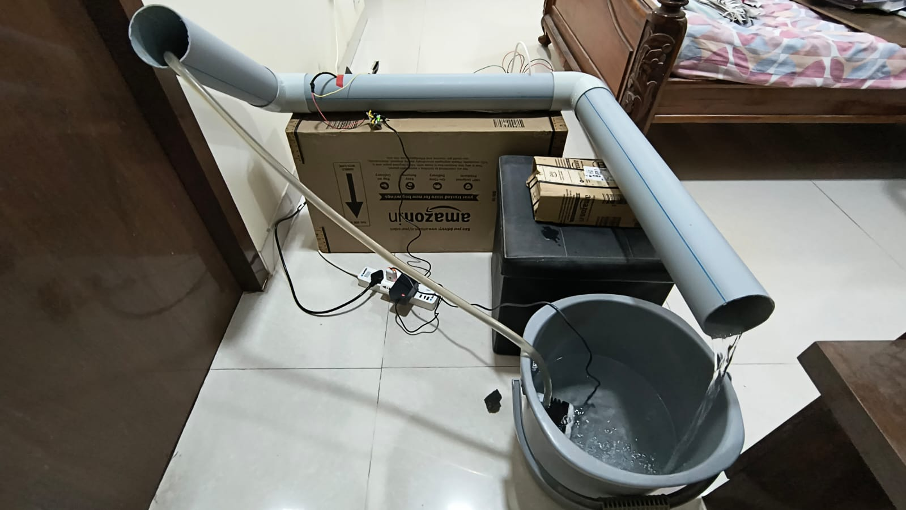

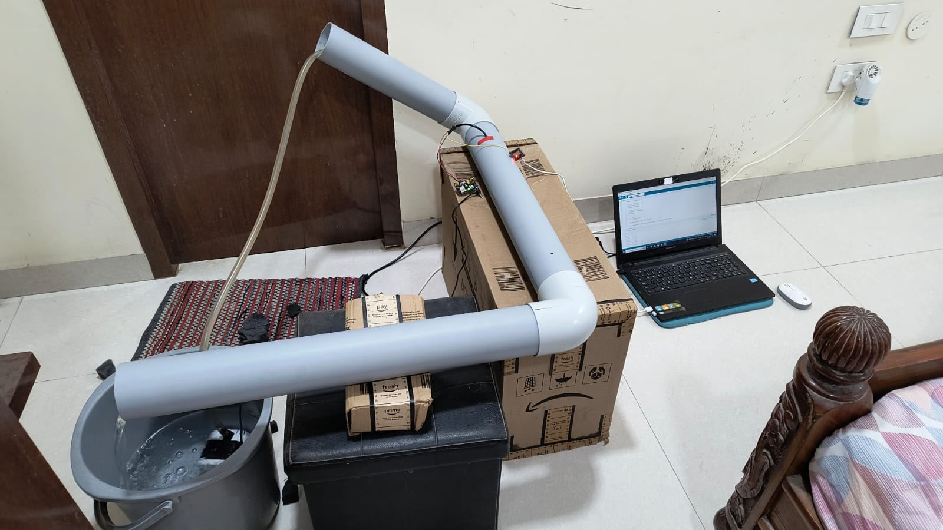
Working model

Decision Logic

if(depth > flood_threshold)
{
CRITICAL FLOOD;
}
else if(flow < 1.7 && pressure > 0.15)
{
BLOCKAGE CONFIRMED;
}
else if(flow < 1.7 || pressure > 0.15)
{
WARNING;
}
else
{
NORMAL;
}

- What aspect(s) of the invention need(s) protection?

Multi-Sensor Fusion-Based Blockage Detection System using ESP32

The invention presents the idea of using a multi-sensor fusion algorithm by collecting and analyzing the data obtained by ultrasonic, flow, and pressure sensors. In this way, all information is analyzed in real time and provides a much more accurate estimation of drainage processes as compared to using only one sensor type. The ability to integrate sensing, processing, and communicating in a compact embedded system is considered a significant innovation feature that needs to be protected.

Integration of Ultrasonic, Flow, and Pressure Sensors for Predictive Detection

The presented invention utilizes water level, flow speed, and pressure readings to observe and detect anomalies. Water level is considered as an indicator of flooding, while flow and pressure readings are used to recognize when there is a possibility of blockages forming. This combination allows for determining what exactly happens at each point of time. Therefore, such an invention is very effective and superior to other traditional methods.

Machine Learning-Based Early Warning Model
the Random Forest model was developed by training on historical drainage data for predicting floods and possible blockages. It is capable of recognizing correlations among different parameters and thus providing an estimate before any critical situations happen. Involvement of machine learning algorithms is a significant innovation and must be patented.

Recirculation-Based Testing Methodology

This invention also consists of bench-top drainage recirculating testing model consisting of PVC piping and pumps to simulate drainage scenarios effectively. It helps conduct repeatable tests as well as introduce artificial blockages within the drainage system without having to test this system in the field. It is indeed an innovative aspect in validating drainage systems.

Hybrid Alert System (Threshold + AI-Based)
This project uses a two-pronged alerting system that makes use of the threshold model as well as predictive learning models to generate alerts. The alerts are classified as either normal, warning, or critical and are sent using mobile alerts, LED indicators, buzzer.

- Approach for Early Detection of Blockage Using Flow and Pressure Indicators

The invention incorporates an effective detection mechanism that uses the flow decrease and pressure increase as key parameters in detecting the blockage even before water level increases significantly. In fact, this is the unique addition that this invention brings into practice through the use of flow and pressure indicators, besides measuring the depth.

- Alternative Detection Techniques (Acoustic or Pulse-Based)

Alternatively, it can incorporate acoustic or pulse-based detection systems to monitor flow variations and sediment deposition at the early stage. This will help detect partial blockages in the channel, which may remain undetected by basic sensors.
©VIT IPR&TTCELL
 | Document No. | 02-IPR-R003
Invention Disclosure Format (IDF)-B
 | Issue No/Date | 2/01.02.2024
 | Amd. No/Date | 0/00.00.0000


9. What is Technology readiness level of your invention? (Tick the appropriate TRL)

 | Research |  |  |  | Development |  |  | Deployment
TRL 1 | TRL 2 | TRL 3 |  | TRL 4 | TRL 5 | TRL 6 | TRL 7 | TRL 8 |  | TRL 9
Basic | Technology | Experimental |  | Technology | Technology | Technology | System | System |  | Actual system
Principles | concept | proof of |  | validated in | validated in a | demonstrated | prototype | complete |  | proven in an
observed | formulated | concept |  | a lab | relevant | in a relevant | demonstration | and |  | operational
 |  |  |  |  | environment | environment | in an | qualified |  | environment
 |  |  |  |  | (industrially | (industrially | operational |  |  | (competitive
 |  |  |  |  | relevant in | relevant in | environment |  |  | manufacturing
 |  |  |  |  | case of key | case of key |  |  |  | in case of key
 |  |  |  |  | enabling | enabling |  |  |  | enabling
 |  |  |  |  | technologies) | technologies) |  |  |  | technologies,
 |  |  |  |  |  |  |  |  |  | or in space )
 |  |  

